An Analysis of Flight Delays at New York City Airports in 2013
A Multiple Logistic Regression Analysis
Jessica Kotlarek
December 17, 2025
Introduction
Flight delays are frustrating, expensive, and extremely common, especially in New York City, one of the busiest air travel hubs in the United States. Delays impact not only passenger itineraries, but they also cause missed connections and create operational challenges for airlines and airports. Nobody benefits from flight delays. There are three major airports in and around New York City: John F. Kennedy International Airport (JFK), LaGuardia Airport (LGA), and Newark Liberty International Airport (EWR). Together, these three airports handle hundreds of thousands of departures each year (typically ~ 300,000). NYC airports present the ideal setting for studying drivers of flight delays because of the high traffic volume.

The goal of this project is to identify the key factors that influence whether a flight departing from a NYC airport arrives more than 15 minutes late to its destination. Officially, the FAA classifies a delayed flight as one that arrives more than 15 minutes late at its destination. This is how the 15-minute threshold was chosen. Using this definition and cutoff, in my project, I analyze the potential drivers of flight delays, selecting variables that I expected to have meaningful relationships with flight delays. Specifically, I focused my analysis on drivers related to airline, origin airport, departure timing, seasonality, and weather conditions. Understanding how these factors are associated with flight delays can help passengers make more informed
travel decisions and manage expectations.
Description of Data
The data for my project comes from the nycflights13 R package, which contains extensive information on all flights departing from New York City airports in 2013. The package contains five tables: flights, airports, airlines, planes, and weather, and I use three of them in my analysis. The primary dataset, flights, includes one observation per flight and records variables such as airline, origin airport, scheduled arrival time, actual arrival time, flight distance, and more. It contains 336,776 observations. I merged this table with the weather table, which provides hourly weather observations, such as wind speed, visibility, and precipitation, for each airport location. I also merged the airlines table to replace airline codes with descriptive airline names to better understand and interpret the data.

I defined the response variable, delayed, as an indicator of whether a flight arrived more than 15 minutes late. Specifically, I set delayed = 1 if the arrival delay was more than 15 minutes, and delayed = 0 otherwise. I initially considered using departure delay, but ultimately chose arrival delay because the arrival time is what essentially impacts the passengers’ experiences.

Flights without recorded departure times represent cancelled flights, and since cancelled flights lack arrival time values, I created a cancelled indicator and excluded these flights from the analysis, because my analysis focuses solely on delayed flights. The exclusion of this data resulted in the removal of 8,255 cancelled flights.

I performed several variable transformations and recoding steps to create meaningful predictors for the analysis. I created the variable departure period by categorizing the scheduled departure hour into four time-of-day groups. These groups are night (12am - 6am), morning (6am - 12pm), afternoon (12pm - 6pm), and evening (6pm - 12am). I chose these groups and times according to the four, six-hour synoptic periods used in meteorological reporting. I treated morning as the reference category because it lies in the middle of the two distributions, number of flights per time of day, and percent of delayed flights per time of day, so it is a good benchmark for comparison.
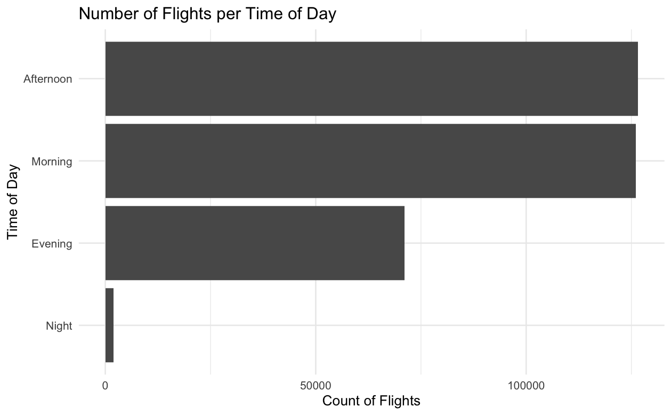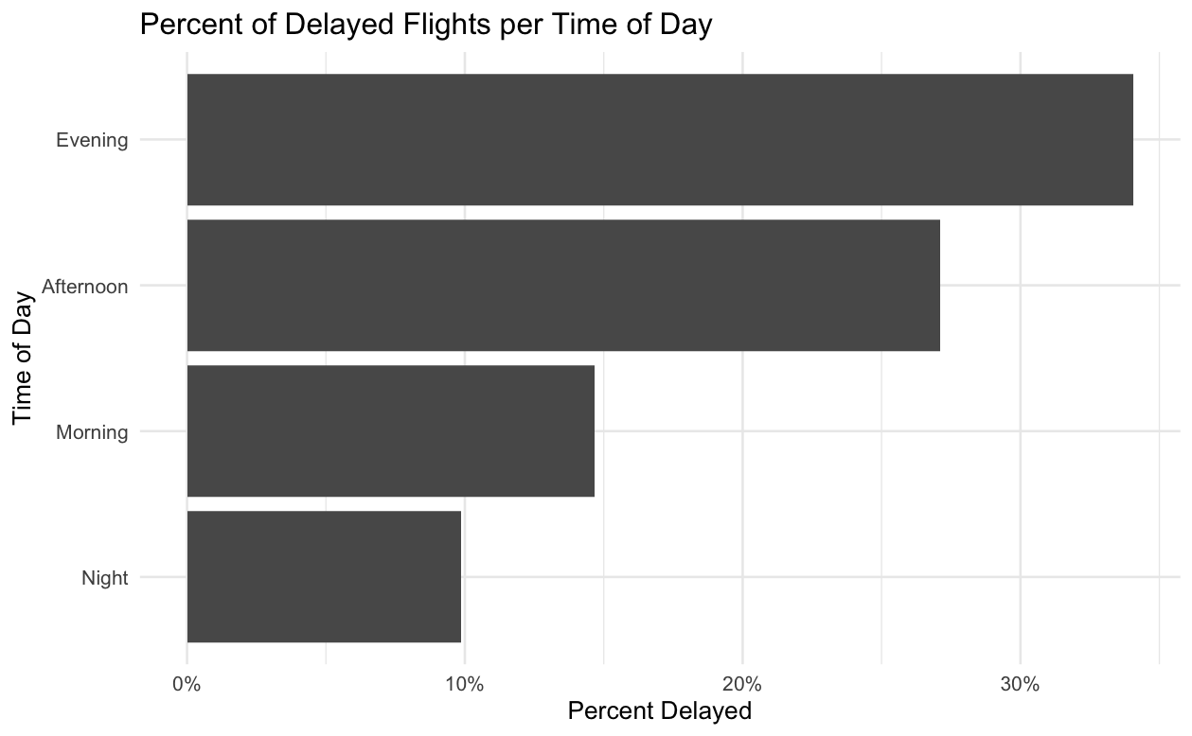
I created an indicator for the weekend by using the departure date. I classified flights as either weekend or weekday based on whether they departed on a Saturday or Sunday, or during the week. I used weekday as the reference level. I created a seasonal variable from the departure month. The seasons and corresponding months are winter (December-February), spring (March-May), summer (June-August), and fall (September-November). Again, I decided the three-month blocks corresponding to the seasons based on the meteorological system. I selected spring as the reference category because, similar to time of day, it falls in the middle of both distributions, so it is a good category for comparison.
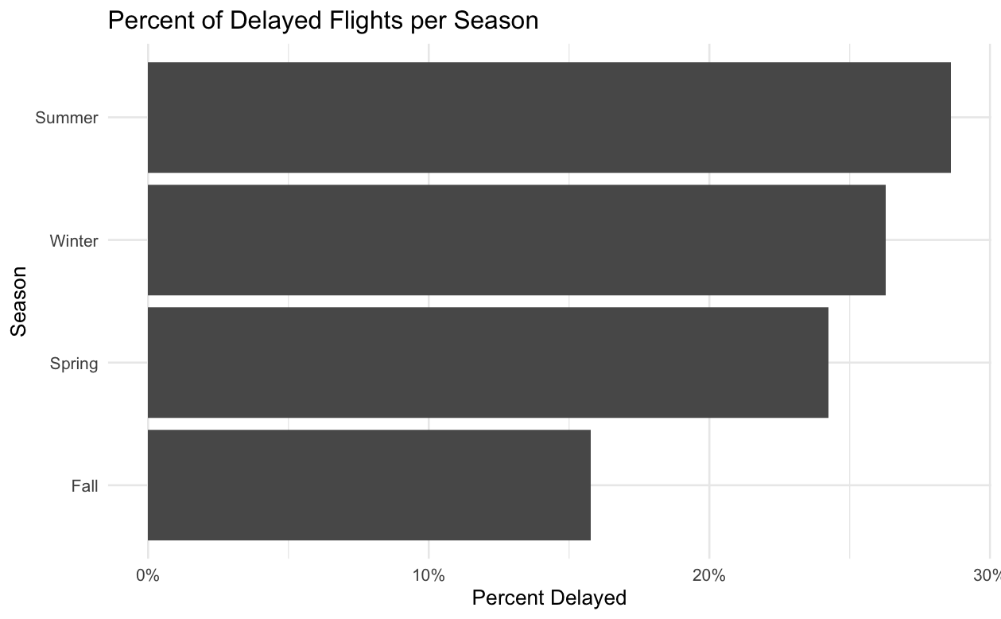
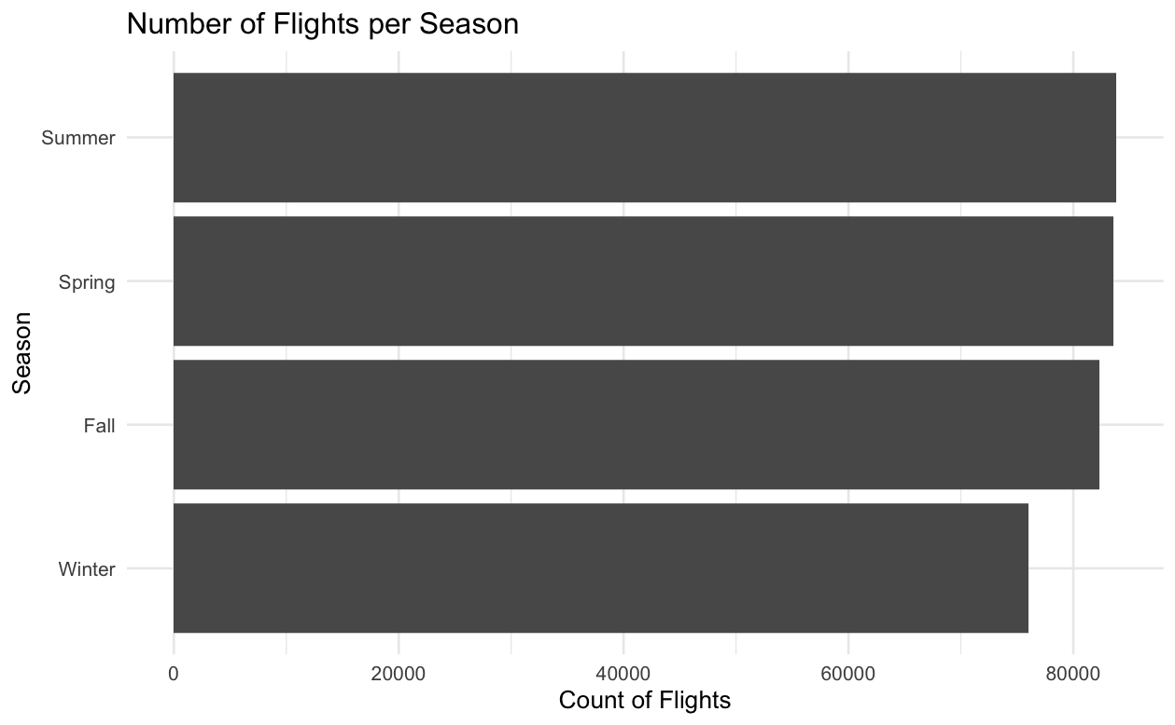

Using hourly precipitation values from the weather data, I defined a precipitation flag as “precip” if precipitation was greater than zero and “no precip” otherwise. I used “no precip” as the reference category. I converted the other two categorical predictors, airline and origin airport, to factors and set the reference levels. For airline, I chose United Airlines as the reference category following because it has the largest number of flights, but the percentage of delayed flights falls in the middle of the distribution, so it makes the comparisons more interpretable.
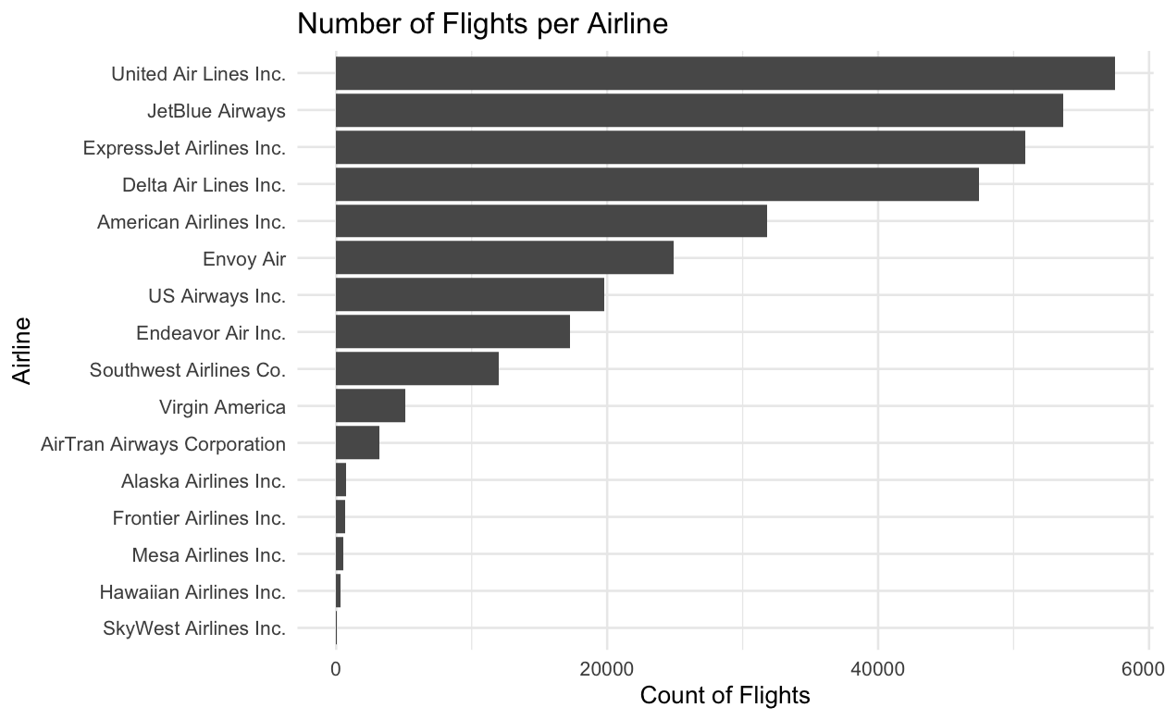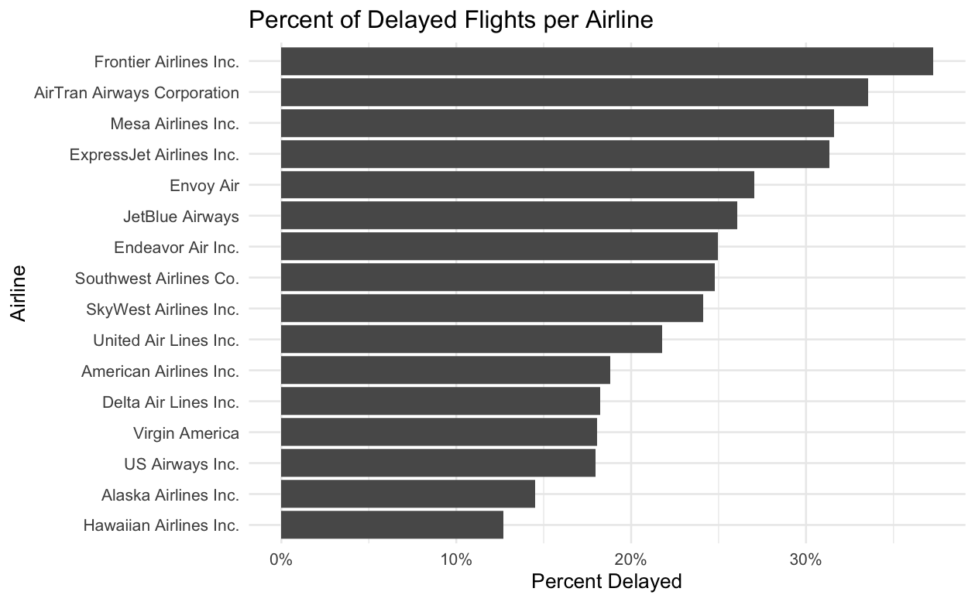
For the last categorical variable, origin airport, I chose JFK as the reference group, following the same decision criteria as earlier, based on choosing a “middle-ground” category.
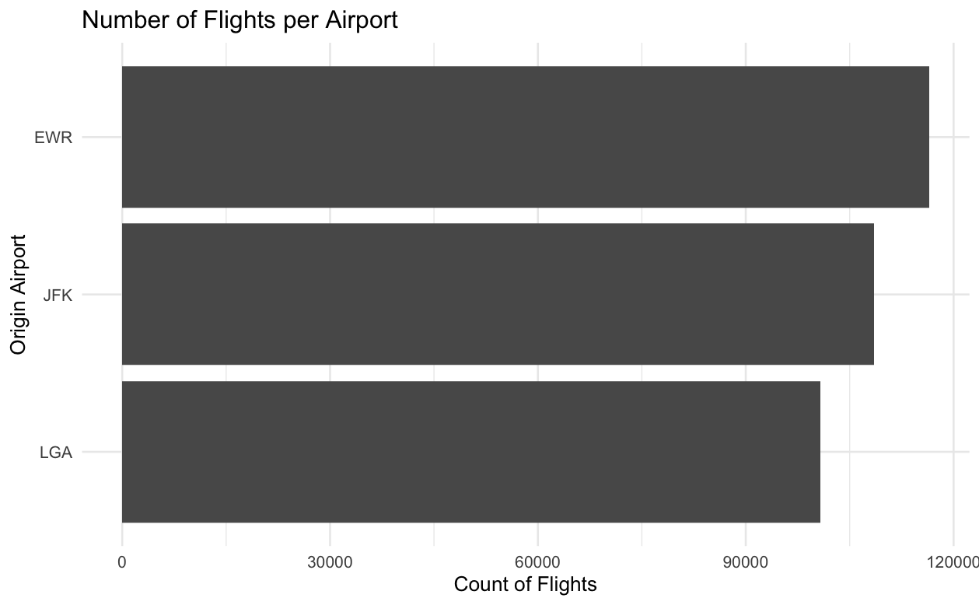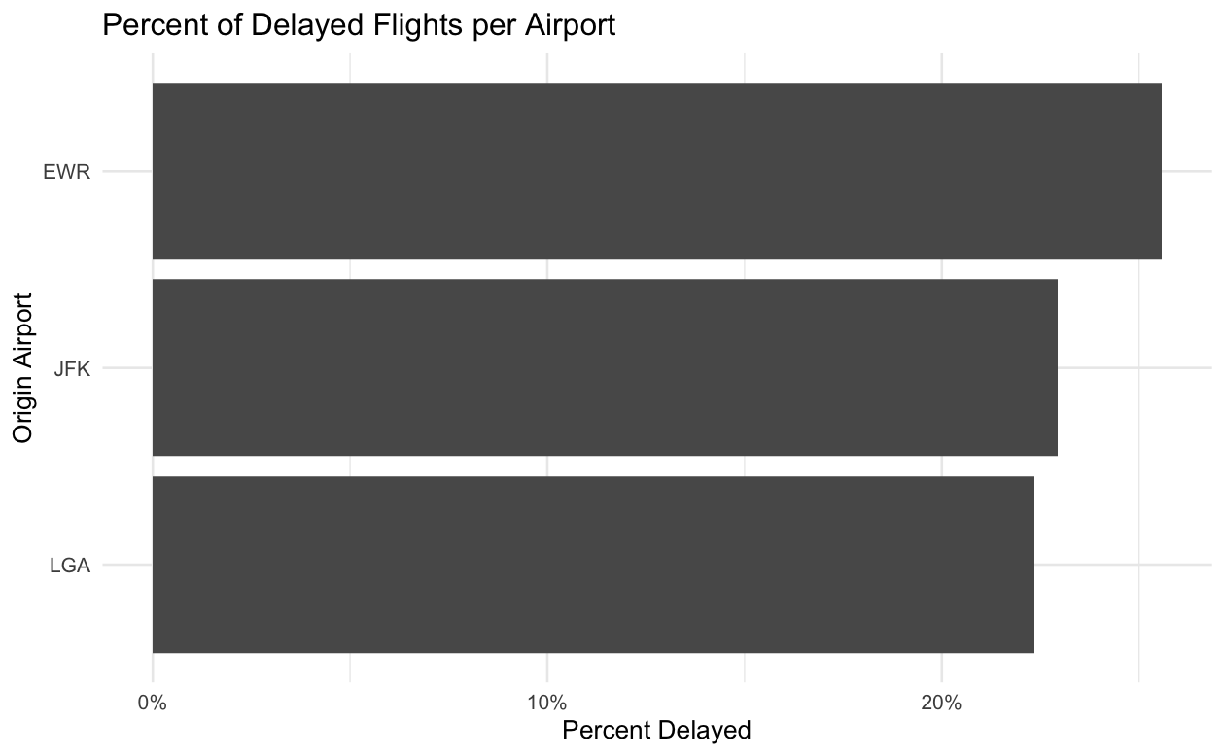
There are three continuous variables: flight distance, wind speed, and visibility. I rescaled flight distance by dividing miles by 1,000 to improve the interpretability of the coefficients. So now, flight distance is represented in thousands of miles, wind speed is represented in miles per hour, and visibility is represented in miles.

After selecting the modeling variables, I examined missingness in the dataset. Most missing values occurred in the response, delayed, due to cancellations. However, additional missing values appeared in some weather variables. When the NA values were all removed, only about 3.3% of the data was eliminated, so I moved forward with the complete-case analysis, dropping the NAs. The final analytic dataset contains 325,741 observations with complete information.

Statistical Analysis
Modeling Framework
Since the response is binary, I use multiple logistic regression to assess which factors are the most significantly associated with flight delays.

Model Selection
I first fit the full logistic regression model, including all predictors, distance, wind speed, visibility, airline, origin airport, departure period, weekend, season, and precipitation flag. I performed three model selection techniques using AIC criterion. These included stepwise (both directions), forward selection, and backward selection. All three models returned the same model, which was the full model, meaning that none of the predictors were removed by AIC-based selection. This result tells us that each predictor contributes enough to the model fit (in the context of the others) that removing it would worsen the AIC. Therefore, I proceeded with the full model and focused on diagnostics and interpretations.

Model Checking and Diagnostics
Assessing independence, the limitation of flight data is that the independence of the flights is not exactly true. Individual aircrafts fly multiple times per day, so delays can add up. For example, a late arrival in the morning can push back a later departure using the same aircraft. This technically violates the independence assumption of logistic regression. However, because the sample size is extremely large and my goal is primarily inference, I treated this as a limitation worth acknowledging but not necessarily detrimental to the analysis. To assess linearity in the logit of the continuous predators, I formally tested linearity using the Box-Tidwell test for wind speed, visibility, and distance. The Box-Tidwell test rejected linearity for all three predictors at the 0.05 level. Based on the estimated Box-Tidwell exponents, I transformed the variables, wind^{0.82}, visibility^{1.62}, and distance^{1.52}. After the transformations, the Box-Tidwell p-values became approximately one, indicating the transformed predictors satisfied the linearity in the logit assumption. I then refit the full model using these transformations and used that model as the final model for inference. To assess multicollinearity, I computed VIFs. All VIFs were less than two, which suggested that multicollinearity is not an issue. To check for influential observations, I checked DFBETAs using a cutoff of 2/$\sqrt{n}$and Cook’s Distance using a cutoff of 4/$\sqrt{n}$. This resulted in about 1,340 observations exceeding the DFBETA cutoff and about 10,372 exceeding the Cook’s Distance cutoff. Though these are large numbers, with ~ 325,000 observations, they are just small fractions of the dataset and are to be expected in massive samples. I proceeded with these values remaining in the model.

Overall Fit and Predictive Ability
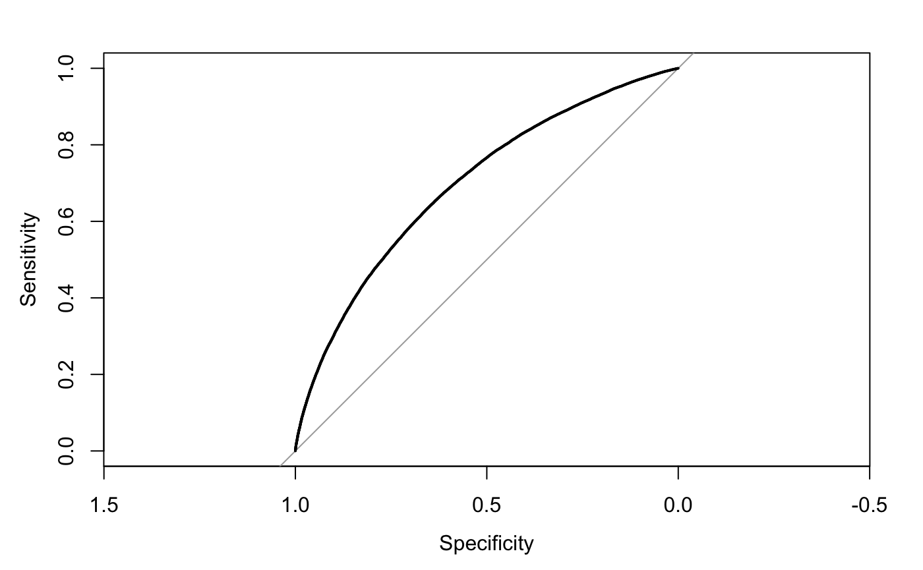
I evaluated my final model fit in multiple ways. I performed a Likelihood Ratio Test, which compared the full model to an intercept only model and showed overwhelming evidence that the predictors collectively explain variation in delay outcomes (as expected with many predictors and a huge sample size). The Hosmer-Lemeshow Test indicated a lack of fit, but this is common and expected in very large datasets because the test becomes overly sensitive. I flagged this but moved past, since it is common in my situation. The AUC was ~ 0.7, meaning the model can correctly distinguish delayed vs non-delayed flights about 70% of the time. This isn’t great, yet, prediction was not the main objective of the project.

I tested two potential interaction terms, origin airport * departure period and season * precipitation flag. I chose these two interactions specifically because I thought traffic patterns might differ at each airport during different times of the day, and I thought seasons might affect precipitation patterns. However, these interactions provided only very small improvements in AIC and Likelihood Ratio Tests. More importantly, adding interactions made interpretations more complicated and caused some previously significant terms to become insignificant. I chose not to include interactions in the final model because with so many predictors already, I didn’t want to overcomplicate the model and lose significance of some of the key drivers.
Discussion
So, after performing a full analysis on what drives flight delays, the best model is:

Variable | Estimate
Distance^{1.52} | 0.02 ***
Wind Speed^{0.82} | 0.05 ***
Visibility^{1.62} | -0.02 ***
Airline, United Airlines | 0 (ref)
Airline, AirTran Airways | -1.54 ***
Airline, Alaska Airlines | -0.66 ***
Airline, American Airlines | -0.12 ***
Airline, Delta Airlines | -0.20 ***
Airline, Endeavor Airlines | 0.19 ***
Airline, Envoy Air | 0 .33 ***
Airline, ExpressJet Airlines | 0.58 ***
Airline, Frontier Airlines | 0.79 ***
Airline, Hawaiian Airlines | -0.19
Airline, JetBlue Airways | 0.30 ***
Airline, Mesa Airlines | 0.48 ***
Airline, SkyWest Airlines | 0.10
Airline, Southwest Airlines | 0.23 ***
Airline, US Airways | -0.16 ***
Airline, Virgin America | -0.14 ***
Origin, JFK | 0 (ref)
Origin, EWR | 0.17 ***
Origin, LGA | 0.13 ***
Departure Period, Morning | 0 (ref)
Departure Period, Night | -0.27 ***
Departure Period, Afternoon | 0.80 ***
Departure Period, Evening | 1.18 ***
Weekday | 0 (ref)
Weekend | -0.34 ***
Precipitation Flag, No | 0 (ref)
Precipitation Flag, Yes | 0.63 ***
Season, Spring | 0 (ref)
Season, Fall | -0.44 ***
Season, Winter | 0.08 ***
Season, Summer | 0.36***

Nearly all predictors in the final model are statistically significant (with extremely small p-values), which is expected with this sample size. When interpreting, we are holding everything else in the model constant. Time of departure is one of the strongest predictors, with afternoon and evening flights having substantially higher odds of being delayed compared to morning flights, which tells us that congestion builds over the course of the day. Rain nearly doubled the odds of delay, while higher wind speeds and lower visibility also increased the likelihood of delay. Newark and LaGuardia had higher odds of delay compared to JFK, suggesting that airport-level factors such as runway congestion or operational procedures may be contributing to the delays. Flights in the fall had lower odds of delay compared to spring, while summer had the highest odds. Additionally, weekend flights were associated with slightly lower odds of delay.

While the model provides useful insights, it has limitations to note. First, the analysis focuses only on flights departing from NYC in 2013, so the results cannot be generalized beyond that to other cities or time periods. Airline operations, airport layouts, and traffic patterns have changed since then as well. Second, my model excluded cancelled flights, which represent a major segment of travel disruption. Although my analysis did not include cancelled flights, this limits the scope of conclusions. There is also a potential concern about overfitting, given the large number of predictors and the very large sample size.

Future work could include an analysis of cancelled flights, rather than excluding them altogether. Also, there is another flights package in R, anyflights, that includes more up-to-date flight data, accessing the data through APIs. A further analysis using this data to be able to broaden the scope of inference and increase generalizability would be an interesting extension to this project.

Overall, although this model does not capture every driver of flight delays, it clearly demonstrates that airline choice, airport, departure timing, seasonality, and weather conditions all play meaningful roles in determining delay risk at NYC airports in 2013.

